05 October 2020

Using SpeedAdmin as a teacher
SpeedAdmin is our database we use for registers and scheduling lessons.

SpeedAdmin can be accessed either online through your browser - Click here
And/Or by downloading the app from app store (apple) or playstore (android).

When you start you will be sent an email with your log in details and the option to choose a password which you will need to use to log into either the web version or the app. (select the create new password option) Please let us know if there are any problems with your password or logging in.

Web version
View the online brief overview video here (you can find all the helpfiles and guidance on the SpeedAdmin page under support)

Important Points
- Please check all details are correct including:
- your personal details
- All the lessons you currently teach appear on your attendance lists
- All the pupils you teach are on there
  - The days and times are correct for each lesson (please let us know individual student times if they are not on the attendance)
- Check that the right number of weeks delivered matches your own records
  - Check the lesson lengths are correct ie 20 mins – if shared 20 min should be inputted as 10 mins
  - Please check that you have enough weeks for the rest of the year. If you do not have enough weeks, please contact Coventry Music

- Please ensure you complete attendance after every lesson as soon as you can (some have been done for you)
- Please ensure you let Coventry Music know of any problems or discrepancies as soon as possible.
- Please ensure you log out after use to avoid any sensitive data being viewed and as per our GDPR policy
- It should all be easy to understand but please let us know if you have any problems.

DASHBOARD
Once you are logged in you will be taken to your teacher dashboard. This is where you can access everything you will need

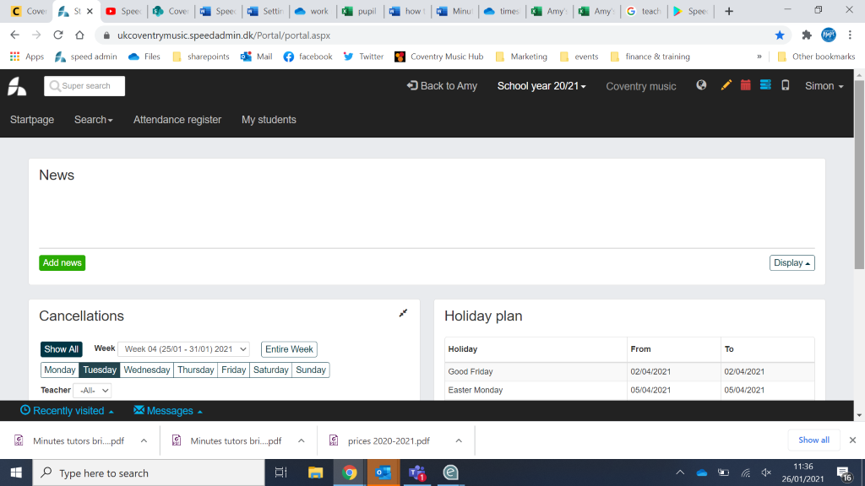

- This is where you will find any important news or updates from Coventry Music.
- Please ensure you read this information each time you log in to check for any important changes
or actions required

- This is where you can see your personal details and make any changes.
- These need to be kept up-to-date
- Please can you check these are correct and fully completed the first time you log in

- 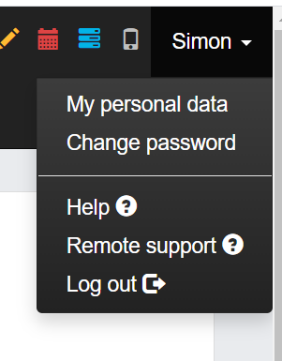

- click on your name, then My Personal Data on the top right
- If you click the blue edit button below your details you can check and change any information and then click the blue save button when complete

REGISTERS
- This is where you can find your registers. They are called Attendance in SpeedAdmin
- 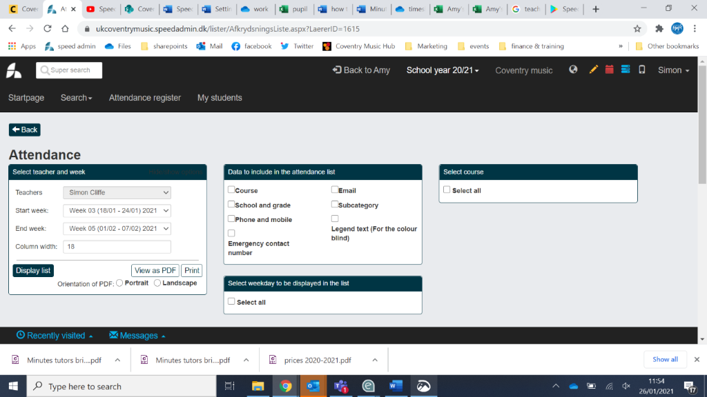
- You have the option to search using specific characteristics and show what information is show using the search options shown above.
- If you want to see previous weeks you need to change the date range and click display list
- If you scroll down the page you will then see a full list of the students and classes you teach.
- You need to check that these details are all correct and let us know of anything that is wrong so we can correct it
- For each lesson you complete you need to click on the correct lesson for each student/class and mark them as attended, or reason for absence if lesson did not take place.
- For individual lessons you need to mark each pupil’s attendance, marking with a reason where necessary.
- Each time you click the colour changes according to the options listed above the list.
- To remove a selection, keep clicking through the colours till it returns to white.
- If you need to reschedule the lesson then you need to click the c
- It is vital this is kept up to date each day, as parents and schools will be able to see if the student attends a lesson.
- Please contact Coventry Music if you do not have enough weeks on your timetable so we can amend it

ICONS
On the top right you will see several icons
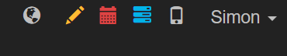

- The first one (the world symbol) shows you a list of notifications
- The second (the pencil) allows you to edit your timetable and add students – PLEASE DO NOT DO THIS AT THE MOMENT – PLEASE NOTIFY COVENTRY MUSIC OF ANY CHANGES THAT NEED TO BE MADE
- The third (the calendar) shows you your current calendar and teaching schedule (please check this looks correct)
- The fourth (the list) shows you a list of the lessons you currently teach
- Please note “lesson” is individual lessons in SpeedAdmin
- And “ensemble” is any lessons/groups/activities with multiple students/shared lessons in SpeedAdmin
(It does not mean music groups like city band as we use the term)
- The last icon (the mobile phone) just takes you to a link to download the mobile app
- If you click on your name you will see various account options, and the ability to log out.

MOBILE APP
If you would prefer and to able to do your registers on the go you can download the app from app store (apple) or Playstore (android).
This video explains more about the app.

