Building Timetable

Select the relevant school year at top of the screen
Select your edit timetable, pen icon as highlighted below
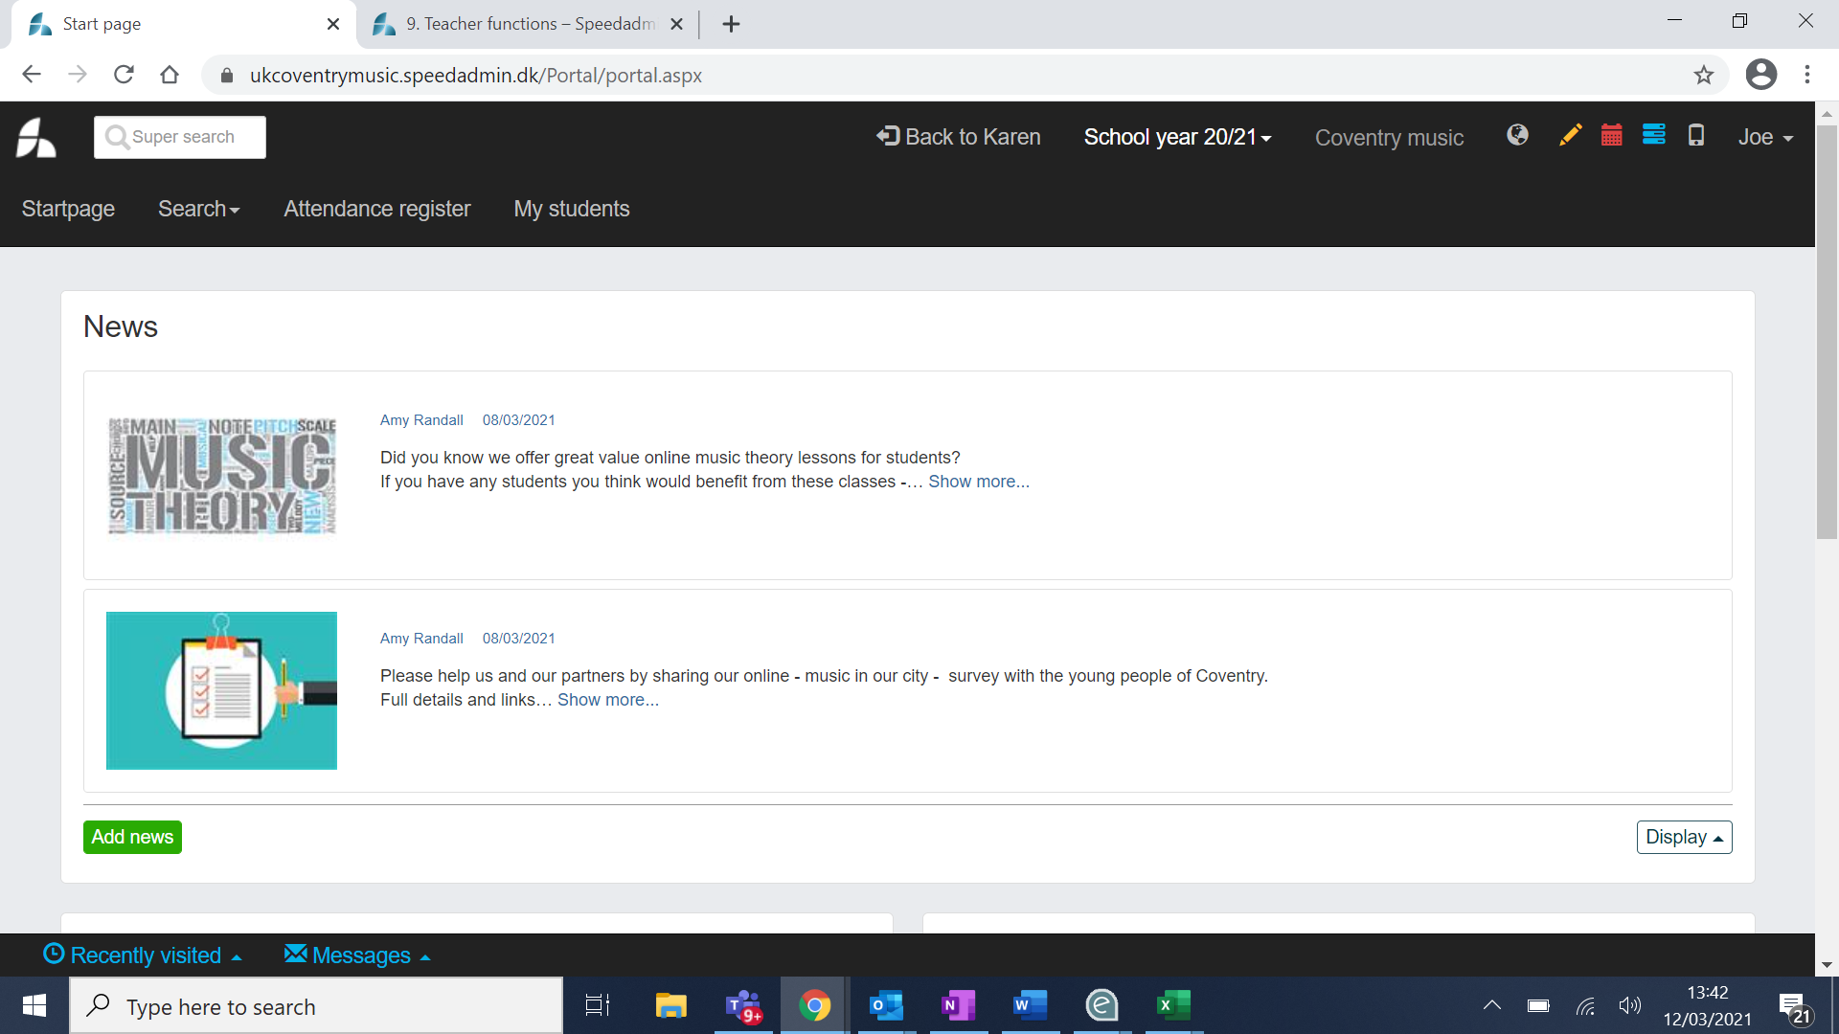

- Your schools/students will appear on the left hand side
- Click on the red padlock to make green and drag each school/student into day and time you require - ensure you select relevant week you will be starting
- Double click on the lesson, select the date tab and schedule your lessons throughout the year so you have 33 blue dots (please ensure you don’t go over 33 – you will not be paid)!
- You can see if this has worked by going into your attendance overview and selecting the week for the beginning of the academic year and ‘to’ the last week of the academic year – check there are 33 sessions
- This may change throughout the year due to absences etc, please follow procedures below

Cancel tuition
Cancelling tuition in Speedadmin is done via “timetable”.
Go to your TIMETABLE and make sure you have selected the correct week. You can change the week by clicking on down arrow and selecting correct week
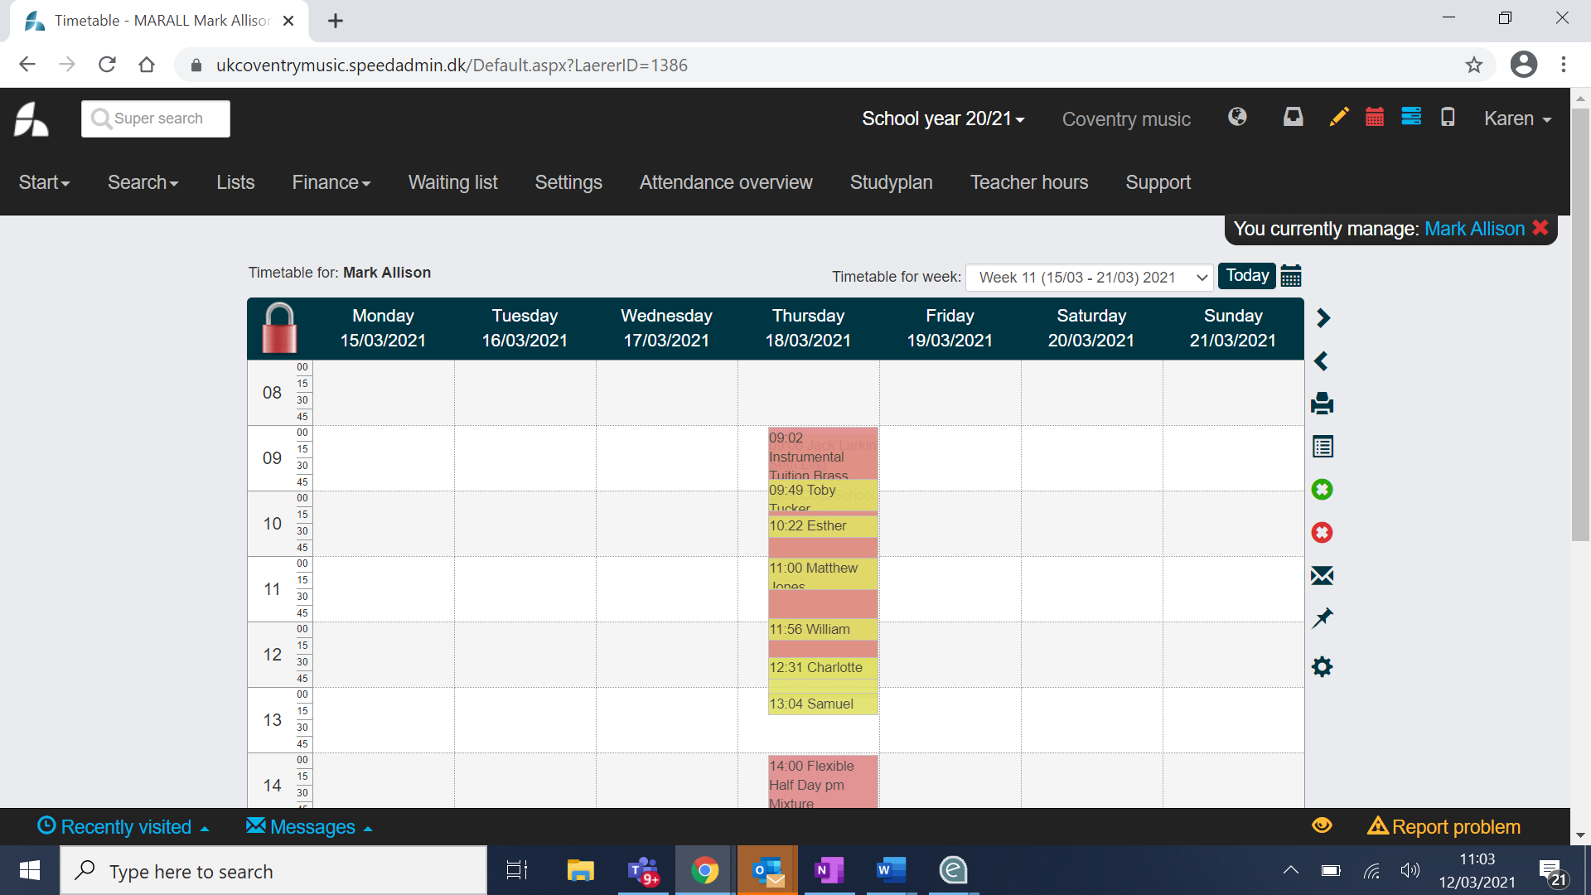
- Click the red-circle icon on the right-hand side of the timetable.
- Use the left mouse button to select the students and/or ensembles that are to be cancelled (all selected bookings will turn dark grey).
- Click ”cancel booking” at the top of the page.
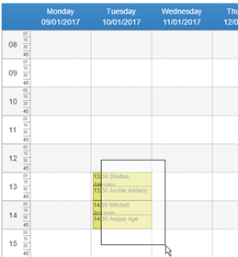

If you have accidentally included too many students or ensemble bookings in the cancellation, it is possible to remove them individually at the bottom of the page now.
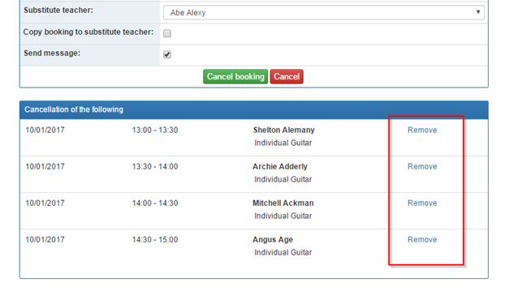
Select a cancellation cause.
- Type in an internal comment – this is visible internally in the organisation only.

- Copy or type in a public comment – this is visible externally i.e. to students or parents who log on to Speedadmin.

- It is possible to indicate a substitute teacher – this will copy all student information to the substitute teacher.
It is also possible to copy the bookings of the students. If bookings are not copied, the substitute teacher must drag and drop the students into his/her timetable via “Edit timetable”.

- Make sure to tick “Send message”, in order to be able to inform the students of the cancellation.
Click “cancel booking” to finish.
______________________________________________________________
Be careful not to cancel tuition that has more than one teacher associated. The other teacher may carry out the tuition as planned.
______________________________________________________________
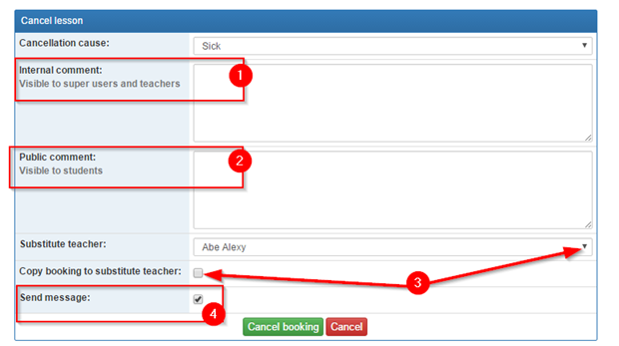

From “messages” you can inform all students and/or parents of the cancellation via sms or email.

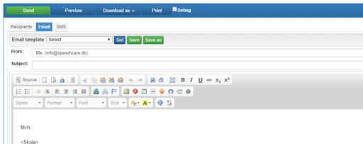

Reschedule bookings
In order to reschedule a booking go to either:
- “Timetable” and click the green circle on the right hand side or
- Click on the pencil

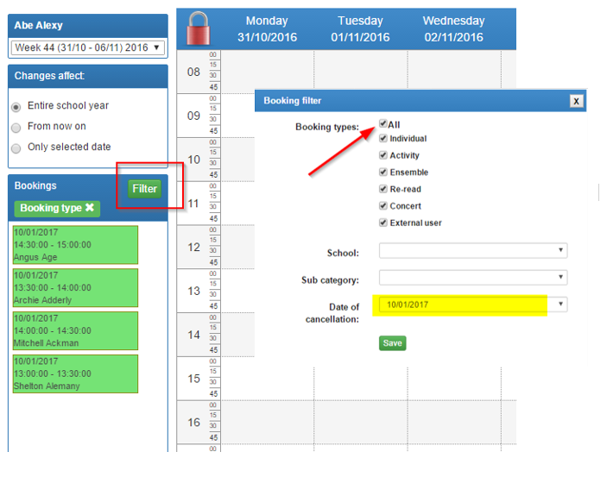
Students or ensembles to be rescheduled appear on the left-hand side in green.
Make sure that “booking filter” on the right-hand side has “All” ticked. It is also possible to select a specific date.

If you have an available room assigned to you, you can just drag and drop the bookings.

Find an available room for your rescheduled booking
If you do not have an available room, you can find one via the needle-eye icon on the right-hand side in “Edit timetable”.
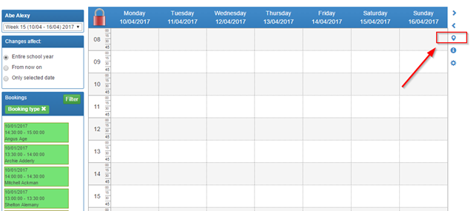
Click a room to select it.
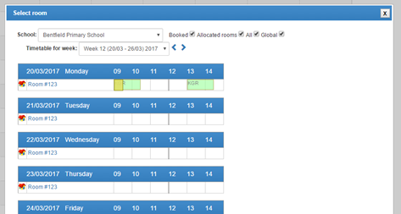

You now see the timetable for the selected room and can find an available slot that fits with your re-scheduled bookings.
______________________________________________________________
Be aware that you have chosen the correct week/date before you drag and drop the bookings into the timetable.
______________________________________________________________

