How to log on to YUMU – Charanga Online Learning At Home

Home Page: https://charanga.com/site/
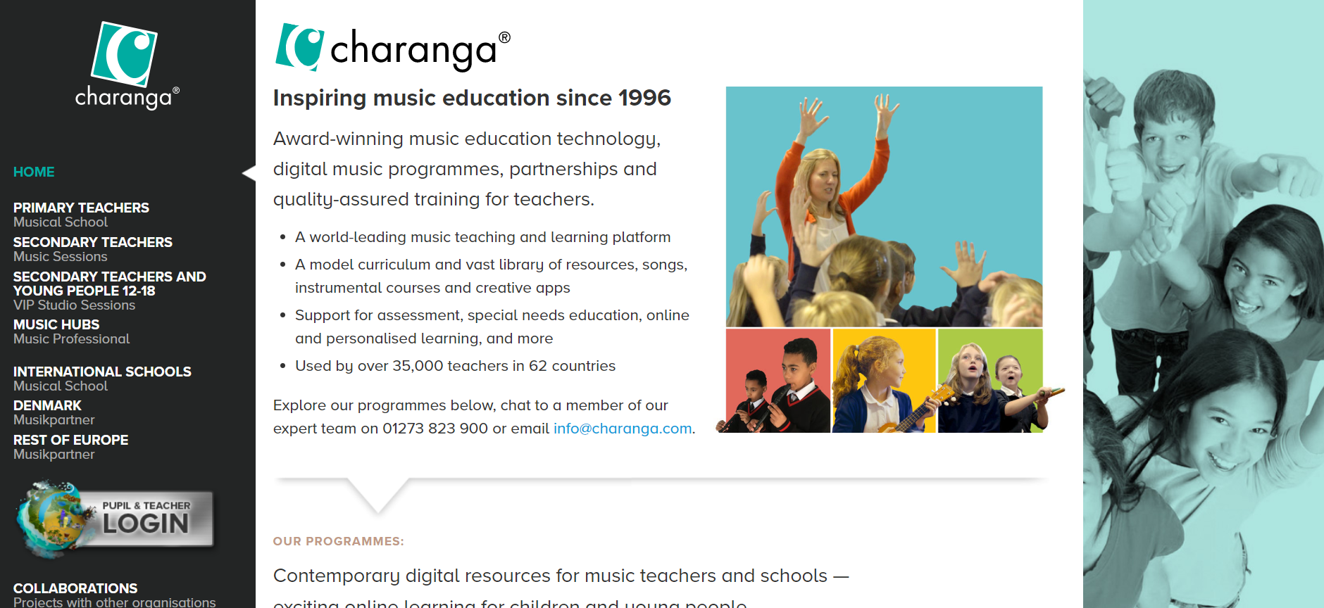

Click Pupil and Teacher Login above – then you get this screen:

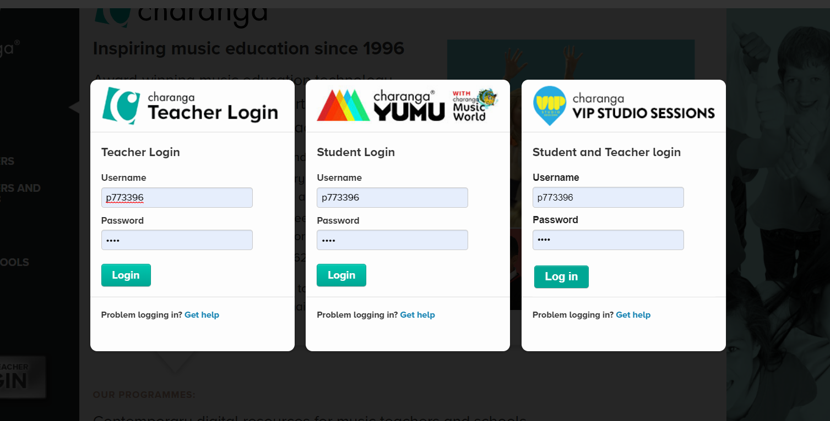

Enter p773396 as Username on the middle login screen (Student Login), then password: gray
These codes are generated by Charanga and directly link to the student groups and lessons that teachers/tutors have prepared.

Then you get to this page:
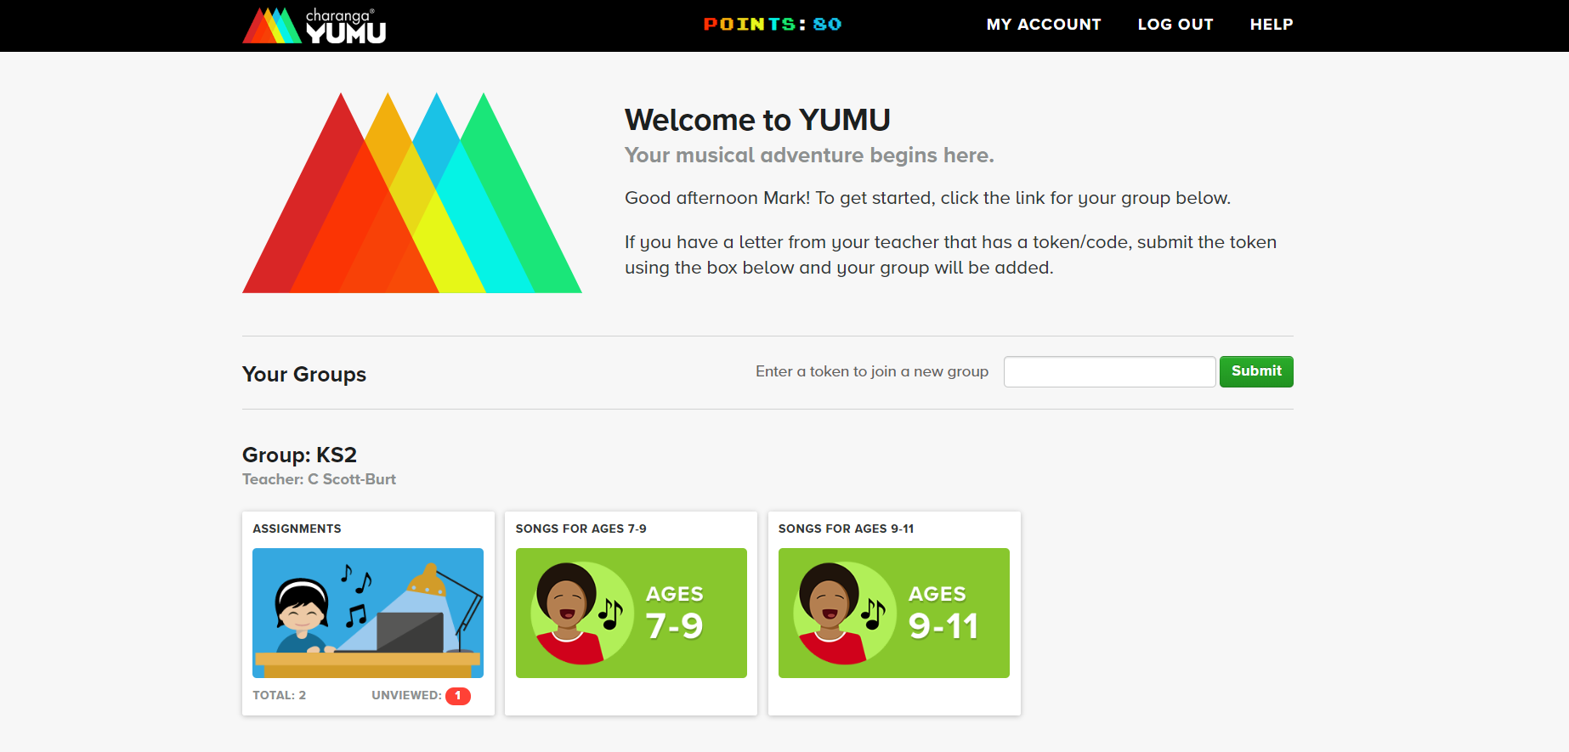
Students can then access any of the resources on Charanga that the teacher has given the pupils access to as shown above.

The login is the same for each student accessing the same lessons as far as I know.

