

Drapers’ Hall

Bayley Lane

Coventry

CV1 5RN

Telephone: **02476 788575**

Email: music@coventry.gov.uk

www.coventrymusichub.co.uk

Dear Parent/Carer

Thank you for considering applying for the Sir Charles Barratt award. To enable you to have the most success with your application please be aware of the following information.

This award can be used for anything in relation to Music Education, Groups, Tuition, Exam fees etc.

Please note instrument purchase is **not normally funded** by the grant.

The cost of tuition through Coventry Music for the 2024/2025 academic year is £41 per hour, therefore a 30 minute individual lesson would be £676 for the school year (33 weeks) or a 20 minute lesson would be £451.

Instrument hire through Coventry Music is £100 per year or free for those who have provision with us.

If you have any further questions or require assistance please contact Coventry Music on the above number or email address.

Please note the closing date for application forms is the **8th May 2024.**

Thank you

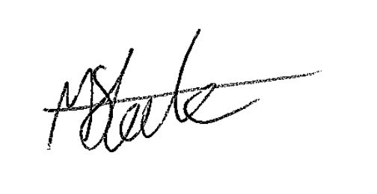

Mark Steele

Lead Coventry Music