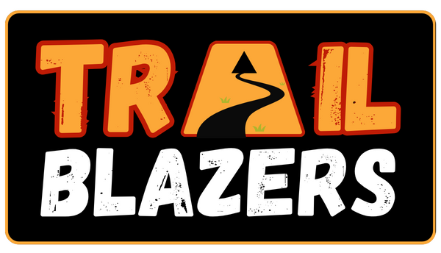

*FREE* KS2 – KS5 BIG SINGING EVENT 2024

“Trailblazers” – A cantata celebrating important people and places
in music and history.
The 12 Song Cantata features an eclectic range of musical styles from across the globe – paying tribute to well-known artists, bands, composers as well as celebrating trailblazers in music and history including George Gershwin, Sir Frank Whittle, The Ancient Egyptians, Rock ‘n’ Roll music and more.
In addition to the KS2 singers, we encourage involvement from musicians and soloists from KS3 – KS5 – contact Kevin directly to discuss opportunities – kevin.stannard@coventry.gov.uk

Songs include:
♫ I Got Rhythm ♫ One Moment in Time ♫
♫ Greeks Bearing Gifts ♫ Ramesses the Great ♫
♫ All Roads Lead to Rome ♫ Starley’s Inventions
♫ In the City ♫ Jet Man ♫ Coventry Cars ♫
♫ Rock ‘n’ Roll Medley ♫ Asikatali ♫

There will be an accompanying scheme of work which outlines all the musical skills and knowledge covered in this project.

PERFORMANCE DATES
Wednesday 26th June & Thursday 27th June
Methodist Central Hall, Warwick Lane, Coventry
The Big Singing Live event gives children the opportunity to sing the songs they have learnt in beautiful surroundings, with other school children, accompanied by a live band – which will include young people and Coventry Music tutors.

Proposed Schedule:
Schools arrive at the Central Hall from 2pm onwards.
Afternoon workshop with the arranger/composer and the live band
all afternoon until 5.15pm (including refreshment breaks)
Tea Break for food and drink 5.15 – 6pm
Performance at 6.30 to finish by 7.45pm
END OF PERFORMANCE

Please note that schools need to make their own arrangements for transport
to and from the venue.

CPD WORKSHOP THURSDAY in April 2024 (TBC)

We will be running an in-person CPD session to learn the songs on a Thursday twilight session in April/May 4.00-6.00pm at Drapers’ Hall to practise the songs and learn more about the live event – date TBC.

Please complete the form below to sign up for the “Trailblazers” Big Singing Live music event June 2024. Please note that places are limited and will be given on a first come first served basis.

Coventry Music “Trailblazers” – A cantata of songs celebrating trailblazers in music and history.

Name of school

Name of main contact

Contact email address

Contact phone number

Key Stage taking part

Year group(s) taking part

Preferred Date  Please choose one and we will do our best to allocate. | Wednesday 26th June ________  Thursday 27th June ________
Approximate number of children/adults  taking part | Children: _____________  Adults: ____________
Are you planning to attend the CPD in April? (DATE TBC) | Yes / No  Name(s) of attendee(s):  _____________________
Coventry Music Support Visit  Would you like a free visit from a member of the Coventry Music vocal team to support a rehearsal with your children in summer term? | Yes/No  What week/s would be best?  _______________________

Signed: __________________________________ Date: _______________________________

Please return this form by FRIDAY 12TH APRIL to music@coventry.gov.uk

