Inclusive Music
Strategy
Coventry Music Education Hub
2023-2027
Dr Phil Mullen

Dr Phil Mullen

Table of Contents
Glossary 4
Introducing the strategy - the national context 7
What was the process? 8
Context 9
A. Demographics 9
B. Education 11
C. Deprivation 13
D. Children in challenging circumstances 18
What is musical inclusion? 18
What does inclusion involve? 12
A note on the strategy 19
Capacity and Funding 19
Workforce development 21
Analysing the data 27
Musical inclusion and children in challenging circumstances 28
Findings based on this lens: 28
Life condition 28
Geographical Issues 30
Background 30
Life Circumstances 32
Young people with social, emotional, and mental health issues 33
List of strategic priorities 35
Action plan 37
Key actions from strategic priorities 48

Glossary of terms and acronyms
Language and terms are changing constantly and rightly so in this field. I have tried to make best use of both up to date terms and terms that are in common usage. I apologise for any mistakes in this area.
AP – Alternative provision - Pupil Referral Units and other forms of educational provision for children who cannot be in mainstream schools.
ARP (or ERP) – Additional Resourced Provision - An ARP is a provision, within a mainstream school, designed to provide specialist and targeted support for children with long term special educational needs (SEN). ARPs are additionally funded which means that a school ARP receives additional resources.
Attainment 8 score - This is calculated by adding together a student's highest scores and averaging them across eight government-approved qualifications at GCSE level.
BAME - or BME – Black and Minority Ethnic – no longer universally used.
CCC – Children in challenging circumstances. A term popularized by the charity Youth Music to describe children and young people who are marginalized, at risk and vulnerable. Still used in this document but being frequently replaced by ‘children experiencing barriers to full participation’.
CPD – Continuing Professional Development
EHC or EHCP – Education and HealthCare Plan
EMTAS – Ethnic Minority and Traveller Achievement Service
FSM – Refers to pupils on free school meals
IDACI - Income Deprivation Affecting Children Index
IMD – Index of Multiple Deprivation
IPPR – Institute for Public Policy Research
LA – Local authority.
LAC – Looked after children meaning children in public care, who are placed with foster carers, in residential homes or with relatives – often referred to as Care Experienced Children
LGBT - lesbians, gay men, bisexuals, and transgendered people
LSA – Learning Support Assistant. Classroom based workers, who may not have a teaching qualification, often helping those with special educational needs.
LSOA - Lower Layer Super Output Areas: LSOAs are areas that have an average population of 1500 people or 650 households.
MOU – Memorandum of Understanding
Music Leader – Person who facilitates group music making.
MYE – Mid-Year estimate
NEET – Young people aged 16-18 not in education, employment, or training.
Non-formal music education – Non-formal music education is usually student centred and is not connected to exams or grades. Often used interchangeably with the term community music.
ONS - Office of National Statistics
PN – Local authority designated priority neighbourhood
PRUs – Pupil referral units, sometimes called short stay schools. Local authority run schools for students who cannot at that time be in mainstream school.
PRU staff – Teachers, Teaching Assistants, Learning Support Assistants, members of the senior management team including heads of school who work in PRUs.
Quality Framework – A flexible Youth Music resource examining quality in inclusive music education.
SEMHD – Social, emotional, and mental health difficulties – This term often includes children that display challenging behaviour.
SEN – Indicating children with special educational needs. Also SEND – Special educational needs and disabilities. Often being replaced with terms such as ALN (Additional learning needs).
SLA – Service Level Agreement
SLT – Senior Leadership Team
TA – Teaching assistant – see Learning Support Assistant.
UPN – Unique Pupil Number
YM or Youth Music – The National Foundation for Youth Music, a lottery funded charity that is the main funder for young people’s music making outside school in England. Youth Music has an emphasis on supporting music provision for children in challenging circumstances.
YOS – Youth Offending Service
YOT – Youth Offending Team

Introducing the strategy - the national context
Both the first and second National Plans for Music Education (2011, 2022) have moved English music education closer to a model that is fully inclusive and provides a high-quality music education for all children and young people, whatever their background. This strategy document reflects an intention in Coventry Music Hub to provide such an education and to, over time, enable all children to benefit from the creative, personal, and social development that music has to offer, particularly for young people experiencing barriers to engagement.
The current national plan states that the Arts Council expect music education to be fully inclusive, so that all music educators:
- commit to achieving greater access and more opportunity in music education, identifying, and removing barriers, including for children in low-income families and children with special educational needs and disabilities (SEND)
- take action to support increasing access, opportunity, participation, and progression of groups that are currently under-represented in music.
- support understanding of inclusive music education and skills development among teachers, tutors, practitioners, and leaders, informed by high-quality research and evidence. (P8)
The plan also identifies the following national priorities for inclusion:
- A strong foundation of music in the early years is vital for all children, but particularly for disadvantaged children or children with SEND. (p17)
- Music education for pupils with SEND must be a long-term provision, sustained, rehearsed, and nurtured carefully through effective personal interaction and collaboration, trust, and time. (p42)
- Schools should not only actively include children with SEND in music teaching but should also consider where music opportunities could be led by pupils with SEND. (p42)
- All APs (Alternative Providers) should consider how they can use music as part of the curriculum and how it can play a valuable role in young people’s education and well-being. Music in these settings can lead to young people learning new skills, working, and creating together, help build confidence and can be used for social and personal development. (p45)
Coventry’s Music inclusion strategy aligns with the national plan and seeks to significantly expand understanding and delivery of inclusive music education over the next four years.
What was the process?
I conducted some online research on the population and demographics of Coventry, the issues, and data around child deprivation within the area, the general profile of the city, and some specifics around services available. I also interviewed (semi-structured interviews) the hub lead and members of senior leadership team that were suggested by the hub lead, some music service staff, people from support and other music organisations and a number of people who work with children in challenging circumstance (CCC). This came to 25 interviews. I then used the two lenses I discuss below to analyse the information I had gathered. From this I drew up this document with the intention to answer the following main questions:
- What are the strategic priorities for Coventry hub in terms of inclusion?
- What actions across the four years of the strategy will best realise these priorities?
The strategic priorities are based on a combination of interview material and my own analysis based on my extensive experience of musical inclusion. While I have some of the objectivity of a professional outsider to the area, I fully acknowledge that anyone else doing the analysis for the strategic priorities may have come to a different conclusion. That said, they do correctly show the results of significant reflection on a relatively large amount of data. I believe them to be appropriate to the local context, aligned with the principles of inclusive education, ambitious and achievable.
Context
Demographics
The population of Coventry has increased by 8.9%, from around 317,000 in 2011 to 345,300 in 2021. This is higher than the overall increase for England (6.6%). Coventry is the 18th largest local authority in England, according to the 2021 ONS Mid-Year Population estimate.
It has a population under 24 of approximately 135,000. Coventry’s median age of residents is 32 years old. As compared to the UK, where the median age of a resident is 40 years and 3 months, Coventry is relatively young (Coventry City Council Headline Statistics February 2022). Just over one-fifth of Coventry’s population, or 79,765 (21.5%) are children and young people under the age of 18 years.
Of Coventry’s children and young people population:
• 22,757 are under 5
• 28,844 (aged 5-10)
• 20,684 (aged 11-15)
• 7,480 (aged 16-17)

Coventry population share by decade of age.
Shares of population age groups compared to corresponding shares of population groups in England & Wales, 2020.
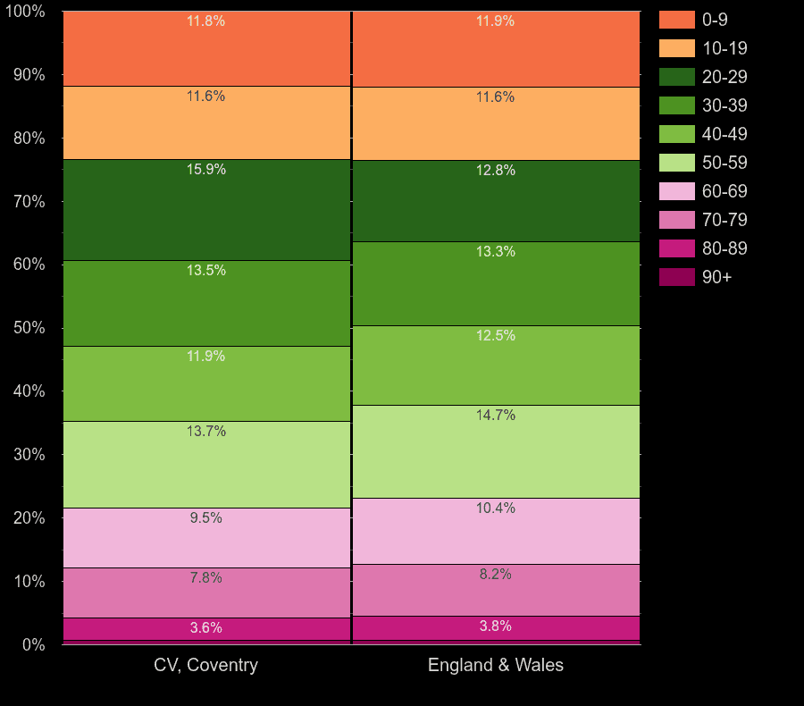
https://www.plumplot.co.uk/Coventry-population.html
Coventry is home to a diverse population, with 33.4% of residents classified as non-white British compared to 20.2% in England, based on 2011 Census data.
Over 66% of the population is White British. Of the remaining residents, 7.2% are White (non-British). Of the BME population, Asian Indian forms the biggest group. Asian people were the largest minority group in Coventry accounting for 18.5% of the population. 30,723 or 9% of the Coventry population are black according to the latest 2021 census.

Population by race in Coventry, 2021 census.
- White - 226,246 people or 65.5%
- Asian - 63,915 people or 18.5%
- Black - 30,723 people or 8.9%
- Other - 12,706 people or 3.7%
- Mixed - 11,731 people or 3.4%
https://www.varbes.com/demographics/coventry-demographics
Education and attainment
In Coventry there are:
85 primary schools/academies
21 secondary schools/ academies
1 all thorough school/academy
8 special schools/academy,
1 nursery school, 1 PRU’s.
- 7 Schools with Special Units attached
- 242 Settings Offering Free Early Years Education
53.1% of Coventry’s school children are from a BME background, up from 39% in 2011.
The proportion of children and young people with English as an additional language:
- In primary schools is 34.4% (the national average is 21.3%)
- In secondary schools is 32.5% (the national average is 17.1%)
- In special schools is 28.6% (the national average is 14.8%)
% of children on Free School meals January 2022
 | Coventry | England
Primary | 24.3 | 23.1
Secondary | 24.5 | 20.9
Special | 45.1 | 44.7

Coventry had 6 times more permanent exclusions in special schools than the English average in 2020/2021.
The number of children who reached a Good Level of Development in the early years foundation stage was 61.1%, below the national average of 65.2% in 2021/2022.
Attainment figures in reading, writing and mathematics were below the national average for the same year at both key stage 1 and key stage 2.
At Key stage 4 attainment 8 scores were below the national average and EBacc entries were approximately half the national figure.
At key stage 5 A level passes at the higher grades were significantly lower than the national average at 8.8% compared to 14.6% for levels A to A* in 2020/2021.
At every key stage Coventry children’s attainment level is below the national average, particularly in terms of those seeking higher grades.
Deprivation
In 2019 Coventry was ranked 81st most deprived out of 317 local authorities. 14.4% of Coventry’s neighbourhoods were amongst the 10% most deprived in the country. 50 LSOAs (Lower Super Output Areas) in Coventry are in the most 20% deprived in England (26% in Coventry compared to 20% across England overall).
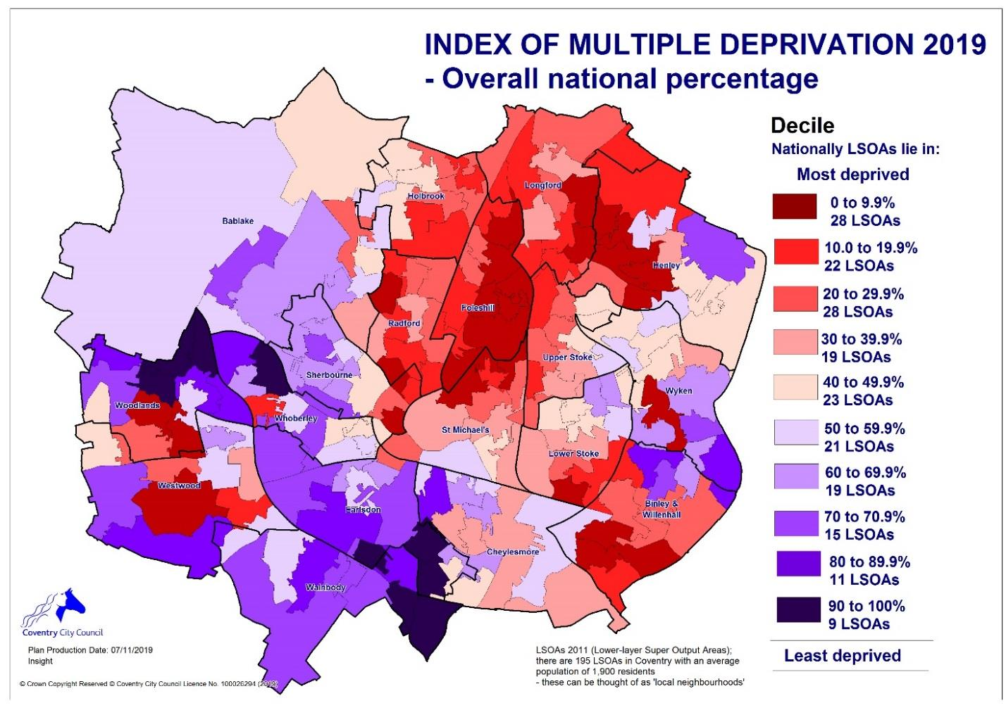

22% of secondary school students in the 2020/21 academic year are in receipt of free school meals. Over one-third (37%) of Coventry children live in low-income families. The impact of this deprivation strongly affects the lives of young people in the city and the hub is right to prioritise work with these young people.
The Coventry and Warwickshire Mental Health Needs Assessment (2021) identified that people living in the 20% most deprived areas were three times more likely to be admitted to hospital with a severe mental illness than people living in the most affluent areas.
Life expectancy at birth in Coventry is slightly lower than in England as a whole—for males it is 78.0 years (vs. 79.6 years in England), while for females it is 82.0 years (vs. 83.1). However, what is more worrying is the wide inequality gap. A man from the most deprived area is likely to die 10 years earlier than one from the least deprived area. The difference for a woman is 8 years (Coventry City Council Headline Statistics February 2022).
Children in challenging circumstances
3,000 young people in Coventry are considered to be at risk of criminal exploitation, with vulnerable members of the community being the most exposed (Coventry Joint Strategic Needs Assessment 2019).
The rate of youth convictions for Violence Against the Person offences increased by 124% in 5 years, and the number of children sentenced to custody is 133% above the national average (Coventry Joint Strategic Needs Assessment 2019).

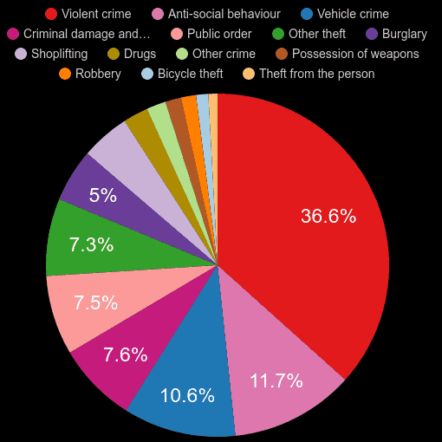
https://www.plumplot.co.uk/Coventry-crime-stats.html

Coventry crime stats July 2023

There are 1,254 (2.3%) school pupils with social, emotional, and mental health needs (2018)
The teenage pregnancy rate is worse than England, with 143 girls becoming pregnant in a year.
According to Coventry City Council’s Youth Justice Strategy and Plan - 2021-23 there are:
- 463 children supported by a child protection plan
- 1901 children in need
- 759 children in care
- 420 care leavers
- 15 Unaccompanied asylum-seeking children (as at end December 2020)
- 5.2% Young people not in education, employment, or training (NEET) or whose activity is not known (% of all 16-17s)
This constitutes a relatively large number of vulnerable children who should be a priority for the Music Hub. While the above data is by no means a complete portrait of the number of children facing barriers to full participation, it does indicate a city that has many children dealing with significant vulnerabilities, who would likely benefit from a holistic, student centred and empowering music education.

What is musical inclusion?
Musical inclusion does not have a single agreed definition; this document contains some different understandings of the term.
‘Musical Inclusion is about removing barriers to ensure all children enjoy full participation in a music education which supports the development and achievement of each young person based on their individual abilities, needs and interests’. – Dr. Phil Mullen
Musically inclusive practice ensures that all children and young people who want to can make music. It can only happen by embracing a wide range of genres and styles, supporting participants to achieve social and personal outcomes as well as musical ones, and having a music education workforce which can work with young people of all backgrounds, needs and interests.
What does inclusion involve?
Inclusion involves change. It is an unending process of increasing learning and participation for all students. It is an ideal to which hubs can aspire, but which is never fully reached. But inclusion happens as soon as the process of increasing participation is started. An inclusive hub is one that is on the move.
(Adapted from Booth and Ainscow, 2002: 3)

A note on the strategy
This is the second musical inclusion strategy written for Coventry music hub. It is my understanding that the first one was implemented in large part and this first strategy has influenced the writing of this current second one.
Capacity and Funding
For any hub implementing an inclusion strategy, it will be a major change in terms of what they do and how they do it. It will also be a major change in terms of the hub’s capacity to do the work and the increased costs that will come, especially in terms of engaging with increasing numbers of children in challenging circumstances (CCC). It is important to recognise that hubs are continually under significant pressure. Those who support hubs, their governance bodies, and funders such as the Arts Council, local authorities, and others, should recognise that asking a hub to do more implies they will need more support. This will be especially true as the hub changes towards becoming more inclusive. Building and sustaining new relationships, providing the project management necessary for working successfully with groups that have not previously been included and providing appropriate training to enable hub musicians to work in unfamiliar ways in unfamiliar contexts will all require investment, particularly so in the first few years of an inclusion strategy. The labour-intensive nature of quality inclusive work suggests that, for hubs to be significantly more inclusive, they will need to engage more children in smaller groups, perhaps for longer time, as some of the work will require more of an emphasis on reflective practice. In addition, there may be some added costs for such things as assistive technology, iPads and other instruments that will aid access.
I recommend that Coventry music hub work with their funders to ensure that a sufficient percentage of funded revenue is allocated annually to inclusive working, in order to ensure that the inclusion strategy is a success. Where data is available on groups it can be useful in guiding the hub to set and realise targets for engagement. The hub will be able to get data on certain groups such as children in care, children on fixed term and permanent exclusion from school, those with SEND etc. Children with SEND alone make up 15% of the national school population so this would indicate that if the hub wants to target and engage with a number of groups in or near natural proportion they will need to ring-fence a significant amount of their funded revenue over time (i.e., by the end of the four year action plan) and they will also need to seek new sources to part-fund the programme. In this way the hub is committing to sustainable resourcing for inclusion. I recommend that the hub, in dialogue with its funders, researches opportunities in order to find a way to ring-fence an amount of funding that is sufficient to realise and sustain this ambitious programme without jeopardising their existing commitments.

Workforce development
Workforce and skills development
“On a granular level could people really explain they why and how of what they are doing?” Manager
Workforce and skills development will be one of the key parts of the inclusion strategy going forward. Coventry hub is changing its team to become more diverse over time in a necessary move to reflect more closely the make-up of the diverse communities of the city. In addition, new tutors are being brought on board to provide skills relevant to the young people’s interests, and partnerships are being strengthened with similar goals in mind. As well as all this, current team members need to become more aware of inclusion in general and some (particularly those working with children with SEND) need to be encouraged to reach a high level of skill and expertise in their inclusive work. Currently, with some notable exceptions, there is a lack of cutting-edge expertise and professionalism both within the hub and its partners and this should be addressed by CPD activities during the course of this strategy.
The changes and development may well be helped by underpinning activities with the model devised by Tom Gilbert and outlined below. Gilbert (1996) expressed possible causes of underperformance by looking at worker’s needs and for each, exploring the role of their manager and of the organisation in supplying those needs. This is the “Gilbert six-cell model.”
These are that they:
• know what to do in their job and to what standard. In a values-driven activity such as working with children in challenging circumstances, the issue of why is an important addition.
• are motivated to do their job.
• are able to do it, which could be interpreted as simple individual skill. However, for a worker in musical inclusion, the issue is more about being enabled to do their job, which brings in organisational issues of being allowed the tools and time and sharing an appropriate culture in addition to simple technical skill.
The Gilbert six-cell model
Workers need to | know what to do, why and to what standard | be motivated to do it | be able to do it
Managers must supply | Clear induction  Regular supervision and co-working | Help for workers to see themselves in the vision.  Appreciation and reward | Individual learning, training, and skill development  Coaching
The organisation must supply | Systems supportive to good management and communication | Creation of a shared vision  Culture of inclusion  Culture of excellence | Culture of (collective) reflective practice  Culture of collaboration

In England today it might be reasonable to suggest that there are two quite different and recognised approaches to pedagogy. Firstly, there is what can be called traditional teaching. This is teaching focused primarily on the development of skills, the imparting of information and the students‘ measurable improvement with specific musical tasks and knowledge set mostly by the teacher. This is very much how many teachers themselves were taught and for many the approach is used without significant critique or questioning. Secondly there is student centred pedagogy, which is based on trust-building, creating safe environments and which empowers young people to be creative and to have a sense of ownership of their goals, achievements, and musical journey. This approach demands ongoing critical reflection.
Both approaches have their merits for particular contexts and all teachers/ music leaders should have a good working knowledge of both approaches. Working in the area of inclusion with children experiencing challenges and barriers to full participation, practice wisdom strongly suggests that the second, student-centred approach is vital to engagement, retention, and potential student transformation. That said, blended approaches with good understanding of the needs of the context, can be very effective.

The different cohorts for specific training/CPD within inclusion are as follows:
- Tutors working in mainstream situations
- Music leaders working with young people with SEND
- Music leaders working in early years or out of school hours programmes especially those working with young people facing barriers to engagement
- Workers from partner organisations

Tutors working in mainstream situations
These tutors should all have a good basic understanding of inclusion, including basic principles such as ‘Universal design’, ‘Normalisation of opportunities’, and the idea that student lack of engagement is a dilemma for the teacher, not a problem within the student. They should also understand the principles of Trauma informed practice, the social model of disability and have a good sense of adaptations including the use of apps, assistive technology, and adaptive instruments within the classroom. While some of this has certainly happened and is continuing in Coventry, my research suggests that a follow-up questionnaire to ascertain what people really know and are comfortable in implementing, will be invaluable.
Music leaders working with young people with SEND
During interviews some music leaders expressed concern that they did not have the skills necessary to work well with these young people. It was also hard to pin down who had the necessary expertise to lead in this area with a number of interviewees saying Kris Halpin although he is not a member of the hub itself. Going forward all music leaders working with young people with SEND should have some induction and training relevant to the group they are to work with. They should all be trained in the social model and the use of adaptive instruments. Other specific training should depend on the nature of the project. No music leader should be put on a project without training or induction in place unless they have proven experience and a comfort in working in this area.
Music leaders working in early years or out of school hours programmes especially those working with young people facing barriers to engagement.
In order to keep in alignment with the national plan, there is a need to expand the team of skilled early years music leaders over the course of this strategy. Because of Coventry children’s specific developmental needs training should, in part, focus on developing language-based work and also creative work. Some training should be done on working with portage children.
For targeted work outside school hours the hub needs a core group of music leaders from diverse backgrounds and with diverse musical skills. The Positive Choices programme has been helpful in identifying both what is and isn’t there in the team. A core group should have a reasonable balance in terms of gender and ethnic background, especially considering the make-up of the city. All this team should have good abilities to undertake a student-centred approach, be creative facilitators with sensitive approaches to communication, and, importantly, their work should be much more empowering than didactic. These skills can be developed through training and open-mindedness.
Workers from partner organisations
Workers from partner organisations can bring the diversity of skills that the young people seek along with a diversity of lived experience, both valuable to the hub. The hub should agree with key partners a set of professional requirements for positive inclusive working and disseminate this across all workforces in Coventry. All funding support should be contingent on working to these professional requirements.
Two other areas of skills development should be mentioned:
- All non-school based projects need an inclusion sensitive approach to project development and management. Some of this was broached during the Positive Choices programme. More work needs to be done on this over the next year and a document, supported by training should be disseminated across the hub and its partners.
- Reflective practice, including advanced understandings of reflective methodologies should be further embedded in the hub during the course of this strategy.
Recommendations for training/CPD
- Further embed structured reflective practice within the hub. I recommend that all new projects with children experiencing barriers have built-in reflection in first year.
- Hub should hold two whole team reflections per annum around areas relevant to inclusion.
- Significant training in SEND for anyone working in this area. Base training on a questionnaire to be sent to team. – Likely to include: Social Model, Sounds of intent, adaptive instruments and technology, use of apps.
- Embed key SEND and inclusive concepts within core team such as social model – for cascading out to freelancers.
- Develop a small number of experts in inclusion, particularly in SEND. Part support advanced training (MA level for example)
- Run short course on getting started in teaching targeting musicians from diverse backgrounds.
- Teams working on major inclusion projects should always meet in advance.
- Document on protocols for project development, targeting and project stability to be disseminated across core team.
- Some further development of creativity within whole class instrumental teaching. CPD on creativity within the mainstream classroom

Analysing the data
To analyse the data, I have used my own taxonomy of children in challenging circumstances (Mullen, 2011) (Deane and Mullen, 2018), which categorises these young people in groupings that would call for different educational/ organizational approaches for each grouping. The lens has room for critique and modification but was immensely valuable in grounding the enquiry. Musical inclusion and children in challenging circumstances (CCC)
A key goal of a musical inclusion strategy is to enable all children, especially those in challenging circumstances, to avail of a useful, high quality and personally suitable music education. Children in challenging circumstances may be categorized in the following groups:
- Life condition - young people with learning difficulties, physical and/or sensory impairment, lifelong complex needs and/or communication difficulties.
- Geographical Issues - Young people with a challenge related to where they live. This could be about such issues as rural isolation or living in areas of social and economic deprivation or issues of geographical safety.
- Identity or background – where issues and structures within the dominant society create inequalities and barriers to musical progression for people with particular identities and backgrounds. That could include gender, ethnicity, sexual orientation, cultural or faith-based backgrounds.
- Life circumstances - Young people who bully or are being bullied, who live in state or foster care, refugees - to name but some.
- Young people with social, emotional, and mental health issues (SEMHD): Young people with social, emotional, and mental health difficulties especially those who become excluded from mainstream school.
(Mullen et al 2011- adapted 2020)
Findings based on this lens:
Life condition
The hub has done good quality work in offering training from Drake music and others and in partnering with organisations such as Soundabout and Open up music (Open Orchestras). This has helped develop significant work with young people with SEND.
The hub now needs to significantly strengthen in-house expertise as well as giving further support to teachers/music leaders currently working in special schools and ERP units.
Young disabled people need regular opportunities to perform and record. This could in part be in partnership with Ego Arts and Open theatre.
In interview I was told that all special schools with SLD and PMLD groups have high quality meaningful engagement with music weekly and also that school staff Have been trained in all 8 special schools so that they feel confident at doing interactive music with all the children in their school and have a range of appropriate skills and knowledge. With this in mind a network should be encouraged and fostered where the special schools are encouraged to collaborate with each other, and this may require project funding from the hub.
The hub needs to review its offer so that a young person with MLD can be guaranteed of a place within an ensemble if they have appropriate musical skills.
Parents need to be assured they can trust the venue, trust the process, and that their child will be meaningfully involved.
Recommendations:
- Develop teachers – establish and support network and action group for all teachers working with SEND students – delegate some funding for project involving multiple schools, designed in partnership with schools.
- Give opportunities for training at high level to establish real expertise especially within hub team.
- Performance, recording and ensemble opportunities to be created.
- Disabled led ensemble.
- Consult with young people and families about the offer and about the inclusivity of the website.
- Create store of accessible instruments
- Engage with enhanced resource provision units.
- Working with other West Midland hubs and organisations such as Soundabout and/or Drake etc., develop training for disabled music artists and educators from across the region.
- Sounds of Intent training for Corley school (open to others)
- Hub to help develop performance and recording in Corley school.
- Set up performance based inclusive ensemble.
- Integrated young producers club – include masterclasses and seminars.
- Hub to do an assessment of all their outside school activities and make reasonable changes and adjustments so that those musicians with MLD with the appropriate musical skills are ensured a place in the relevant appropriate ensemble.
- Training around PMLD (intensive interaction etc.)
- Invest in a store of accessible instruments.
Geographical Issues
I recommend the hub continue to place new music projects around Coventry and not just in Drapers hall. If possible new work should be targeted in areas both of high deprivation and high and rising crime and this work should be targeted at those young people both who are at risk of crime and also those who might benefit most from engaging in music within a challenging area of the city. Henley Green, Hillfields, Wood End, Bell Green, Willenhall, and Lower Eastern Green are all in the top five percent of the most deprived areas in England and should be considered for pilot projects, including taster sessions that can be built on. Areas of the city that have high or rising crime are also a consideration, including Clifford Park, Willenhall, and Longford. These areas would benefit from pilot projects done in partnership with the Youth Justice Team and also after schools work similar to the Positive Choices programme.
Background and identity
Given the highly diverse nature of the city it is perhaps not surprising that some people are experiencing discrimination and hatred based on their background. In Warwickshire (Coventry only figures not available) there were 489 offences committed in the area in the year ending March 2022 that were believed to be aggravated or motivated by either racism or religious intolerance. That is 26% higher than the previous year and a 35% increase on pre-pandemic figures. It is also the highest number on record and 89% higher than the 259 crimes recorded a decade ago in 2011-12. The number of hate crimes recorded by police across the West Midlands region has risen by 35%, the second highest in the country.
The hub should seek to, over time, develop a workforce that looks like the city and represents the musical interests of young people in the city. It should seek to support small education projects within specific communities. It should foreground the musics of those communities in its teaching and repertoire and seek also to develop cultural ensembles, open to all. Much of this work will, during the course of the strategy, be about relationship building and the outcomes may at first be tentative, but it is important to move in this direction. Traditionally excluded groups such as Romanies, Gypsies and Irish Travellers should be prioritised, as should new arrivals, especially given the current political climate. Recommendations include:
- Develop project with Romany youth at Sydney Stringer Academy
- Pilot project with EAL new arrivals – partnership with migration team for referrals
- In partnership with migration team and Positive Youth Foundation offer small number of diverse open days for immigrants and refugees. This could include Ukrainian / Balkan brass as well as a range of other activities. Follow up with 1 to 1s or ensemble group as appropriate.
- Seek referrals from migration team for piano students from Hong Kong
- In partnership with Ukrainian centre seek to develop child choir to complement current adult choir.

Life Circumstances
This category involves a range of groups of children who can often fall through the cracks in terms of music provision. It includes young carers, children of armed service personnel, bereaved children, children who are looked after and many other groups and individuals. Often, they are more easily targeted through work done outside schools, sometimes in partnership with the local council and almost always in partnership with non-music specialist organisations.
The hub should seek to develop partnership with a range of non-music organisations, especially through Positive Youth Foundation, if possible. This work should be done as pilot projects, outside school hours, using an expanded core delivery team led by Mark Patton and Joe Cook.
Recommendations:
- Pilot family group with foster carers and care experienced children from years 5 to 7 over 6 weeks leading to performance. Open it up to Virtual school staff. Optimum length 6 to 8 weeks.
- If successful develop ongoing creative ensemble with same general cohort
- Pilot short ensemble programme with care experienced young people post 16 years
- Explore possibility of developing partnership with Bath Philharmonia and Jason Thornton to do creative ensemble work with young carers. Carefully build in legacy (e.g., ensemble/ blended ensembles) before beginning programme.
- Set up opportunities in Hillfield area for young women to engage in song writing and production work. Work with local providers and schools to develop referrals over time
- Pilot programme with Attendance Inclusion Team with young people not regularly attending school
- Develop music programme with teenage mothers based on creativity and fun.
Young people with social, emotional, and mental health issues (SEMHD)
The substantive issues around the historic rise in crime, particularly violent crime, in Coventry could easily mask the needs around isolation and mental health difficulties that affect other parts of the Coventry youth population, especially girls. The hub is right to identify SEMHD as a priority in the city and should build on the work begun with Positive Choices. Over the course of the strategy the hub needs to continue to develop the work they have been doing in extended learning centres. The hub should also develop work at primary level with all young people permanently excluded who want to do music and a number who have been temporary excluded. These programmes should continue from primary across to at least year 7.
The team needs to be expended to include female music leaders with band and production skills who can develop empowering programmes with teenage girls at risk.
Specific recommendations:
- Prioritise responding to 20-year historic increase in Gang activity
- Offer support to partners working with at risk young people in areas such as training for transformation
- Whole class provision at Primary AP
- Offer to work with all young people excluded at primary age
- Link with Faith schools for wellbeing programme
- Setup creative and empowering band and song writing workshops for girls aged 13 to 16
- Rework Service level agreements with schools to ensure that vulnerable children (particularly those with challenging behaviour) are no longer taken out of music lessons
- Explore possible referrals and partnership work with Compass Coventry
- Closer links with Police Service on developing shared knowledge around Drill music – bring in suitable representatives from young people

List of strategic priorities
Strategic Priority 1
Both the make-up of the team (including regular partners) and the music offered by the hub has diversified to more closely reflect the diverse cultures represented within the city and the interests of the young people the hub wishes to engage.
Strategic Priority 2
The programme of music engagement outside school hours has continued and has expanded to include specific targeted groups.
Strategic Priority 3
The workforce has appropriate, sufficient skills to deliver musically inclusive practices with all children and young people. Some of the workforce are at expert level within their area of inclusion. There is a core team within the hub who are skilled professionals in inclusive practice.
Strategic priority 4
There is a widely held perception of the hub as one that embraces and foregrounds inclusion and diversity. Hub communications, including the website, have been reviewed and updated and there is raised awareness of the hub’s role and the opportunities available for inclusive music-making.
Strategic priority 5
Quality of practice in inclusive music is reviewed and upgraded, including both project delivery and project management. This is underscored by a commitment to structured reflective practice from the whole workforce.
Strategic priority 6
The offer for children with SEND has been expanded.
Strategic priority 7
The hub has increased and sustained engagement with children with SEMHD, including young women at risk and young people at risk of gang involvement or exploitation.
Strategic priority 8
The hub has engaged with a range of new partners across the city and has deepened engagement with existing partners. All partners have agreed on professional expectations for quality inclusive working. Where appropriate new professional networks have been developed.
Strategic Priority 9
The delivery of music tech across the hub (including with partners) has been expanded, particularly to foreground the use of assistive/adaptive technology.
Strategy priority 10
Music making in the early years has been further developed, with inclusion at the forefront.

Action plan
Strategic Priority 1 | Both the make-up of the team (including regular partners) and the music offered by the hub has diversified to more closely reflect the diverse cultures represented within the city and the interests of the young people the hub wishes to engage.
Year 1 2023-2024
- Offer targeted volunteering /shadowing opportunities to BAME and also disabled musicians.
- Develop Contemporary (Grime/Drill) programme for offer to secondary schools.
- Ensure that all delivery team have a bank of culturally diverse songs and/or resources to use in their teaching.
- Identify potential stakeholders for future South Asian music initiative – from education, parents’ groups, music, faith leaders, possible sponsors. The programme should, while including traditional elements, also emphasise contemporary South Asian music and partners should reflect this.
- Create database of local music educators from a range of diverse backgrounds
- In partnership with migration team and Positive Youth Foundation offer small number of diverse open days for immigrants and refugees. This could include Ukrainian / Balkan brass as well as a range of other activities. Follow up with 1 to 1s or ensemble group as appropriate.
Seek referrals from migration team for piano students from Hong Kong
Year 2 2024-2025
- Continue volunteering/shadowing programme. Begin using interns from under-represented groups where possible.
- Where possible, use positive action to create new employment opportunities for musicians from under-represented communities.
- Continue to expand workforce to represent more diverse genres - find appropriate deliverers for contemporary music including various hip-hop styles.
- Build relationships, foster a network around South Asian Music provision. Engage in dialogue with young people, schools and education providers, communities and community leaders on issues including barriers to engagement
Year 3 2025-2026
- By year 3 governance bodies will have been reviewed to more closely reflect the make-up of their communities.
- Where possible create new employment opportunities for musicians from BAME and other under-represented communities
- Initiate pilot activities around South Asian music Education network – hub to support. Lead must come from community.
- Create at least one new cultural ensemble.
- Pilot project with EAL new arrivals – partnership with migration team for referrals
Year 4 2026-2027
- Develop festival of Coventry communities in music education
- Pilot 2nd new cultural ensemble

Strategic Priority 2 | The programme of music engagement outside school hours has continued and has expanded to include specific targeted groups.
Year 1 2023-2024
- Continue after school music programme in challenging areas.
- Pilot family group with foster carers and care experienced children from years 5 to 7 over 6 weeks leading to performance. Open it up to Virtual school staff. Optimum length 6 to 8 weeks.
- If successful develop ongoing creative ensemble with same general cohort
Year 2 2024-2025
- Set up opportunities in Hillfield area for young women to engage in song writing and production work. Work with local providers and schools to develop referrals over time
Year 3 2025-2026
- Pilot programme with Attendance Inclusion Team with young people not regularly attending school.
- Develop music programme with teenage mothers based on creativity and fun.
- Explore possibility of developing partnership with Bath Philharmonia and Jason Thornton to do creative ensemble work with young carers. Carefully build in legacy (e.g., ensemble/ blended ensembles) before beginning programme.
Year 4 2026-2027
- Pilot short ensemble programme with care experienced young people post 16 years

Strategic Priority 3 | The workforce has appropriate, sufficient skills to deliver musically inclusive practices with all children and young people. Some of the workforce are at expert level within their area of inclusion. There is a core team within the hub who are skilled professionals in inclusive practice.
Year 1 2023-2024
- Develop short inclusion CPD programme - Deliver for all relevant hub team and invited partners - programme to include emphasis on shared ownership and creative music making.
- Partnership agreements to be revised to include a commitment to inclusive practice with appropriate training as needed.
- Further embed structured reflective practice within the hub. I recommend that all new projects with children experiencing barriers have built-in reflection in first year.
- Teams working on major inclusion projects should always meet in advance.
- Document on protocols for project development, targeting and project stability to be disseminated across core team.
- Embed key SEND concepts within core team such as social model – for cascading out to freelancers
Year 2 2024-2025
- Inclusion induction/training to be a requirement for any organisations financially supported by the hub if appropriate.
- Any new employees and volunteers are required to engage with induction/training unless already having appropriate experience.
- Run short course on getting started in teaching targeting musicians from diverse backgrounds
Year 3 2025-2026
- Hub should hold two whole team reflections per annum around areas relevant to inclusion.
- Significant training in SEND for anyone working in this area. Base training on a questionnaire to be sent to team. – Likely to include: Social Model, Sounds of intent, adaptive instruments and technology, use of apps.
- Some further development of creativity within whole class instrumental teaching. CPD on creativity within the mainstream classroom
Year 4 2026-2027
- Develop a small number of experts in inclusion, particularly in SEND. Part support advanced training (MA level for example)

Strategic Priority 4 | There is a widely held perception of the hub as one that embraces and foregrounds inclusion and diversity. Hub communications, including the website, have been reviewed and updated and there is raised awareness of the hub’s role and the opportunities available for inclusive music-making.
Year 1 2023-2024
- Consult with a broad range of young people and stakeholders on their perceptions of the inclusiveness and relevance of the hub and what they want to see going forward.
- Review website and social media and other communications with inclusion specifically in mind.
- In relation to the above, seek some advice from SEND or other relevant music and social media specialists as well as young people and parents.
Year 2 2024-2025
- Update websites and social media based on previous years investigation.
Year 3 2025-2026
- Initiate marketing campaign promoting musical inclusion and the hub
Year 4 2026-2027
- Consult again with young people and review progress

Strategic Priority 5 | Quality of practice in inclusive music is reviewed and upgraded, including both project delivery and project management. This is underscored by a commitment to structured reflective practice from the whole workforce.
Year 1 2023-2024
- Document on protocols for project development, targeting and project stability to be created.
- Continued use of quality framework
- Teams working on major inclusion projects should always meet in advance.
- Further embed structured reflective practice within the hub. I recommend that all new projects with children experiencing barriers have built-in reflection in first year
Year 2 2024-2025
- Document on protocols for project development, targeting and project stability to be disseminated across core team.
- Partners giving training in quality framework and professional excellence.
- Hub should hold two whole team reflections per annum around areas relevant to inclusion
Year 3 2025-2026
- All partnership projects with national organisations to have built in CPD for hub team.
- Training is offered to all partners on reflective practice
Year 4 2026-2027
- Online practice sharing is encouraged.
- Short training programme on deepening reflection

Strategic Priority 6 | The offer for children with SEND has been expanded.
Year 1 2023-2024
- Invest in a store of accessible instruments.
- Consult with young people and families about the offer and about the inclusivity of the website.
- Performance, recording and ensemble opportunities to be created.
- Hub to help develop performance and recording in Corley school
Year 2 2024-2025
- Develop teachers – establish and support network and action group for all teachers working with SEND students – delegate some funding for project involving multiple schools, designed in partnership with schools.
- Working with other West Midland hubs and organisations such as Soundabout and/or Drake etc., develop training for disabled music artists and educators from across the region.
- Hub to do an assessment of all their outside school activities and make reasonable changes and adjustments so that those musicians with MLD with the appropriate musical skills are ensured a place in the relevant appropriate ensemble
Year 3 2025-2026
- Engage with enhanced resource provision units.
- Set up performance based inclusive ensemble.
- Integrated young producers club – include masterclasses and seminars.
- Give opportunities for training at high level to establish real expertise especially within hub team
Year 4 2026-2027
- Disabled led ensemble.
- Sounds of Intent training for Corley school (open to others)
- Training around PMLD (intensive interaction etc.)

Strategic Priority 7 | The hub has increased and sustained engagement with children with SEMHD, including young women at risk and young people at risk of gang involvement or exploitation.
Year 1 2023-2024
- Rework Service level agreements with schools to ensure that vulnerable children are no longer taken out of music lessons.
- Whole class provision at Primary AP
- Offer support to partners working with at risk young people in areas such as training for transformation and trauma informed practice
Year 2 2024-2025
- Link with Faith schools for wellbeing programme
- Closer links with Police Service on developing shared knowledge around Drill music – bring in suitable representatives from young people.
- Pilot expanding work with secondary exclusion centres to 4 to 6 hours contact time per student per week if possible
Year 3 2025-2026
- Offer to work with all young people excluded at primary age.
- Setup creative and empowering band and song writing workshops for girls aged 13 to 16
Year 4 2026-2027
- All activities are underpinned by basic psychological wellbeing (Self Determination Theory – Deci and Ryan)

Strategic Priority 8 | The hub has engaged with a range of new partners across the city and has deepened engagement with existing partners. All partners have agreed on professional expectations for quality inclusive working. Where appropriate new professional networks have been developed.
Year 1 2023-2024
- Develop a document outlining inclusive values and practices to embed inclusion with all hub workers and appropriate partners.
Year 2 2024-2025
- Hub partners take on responsibility to:
Provide data on who is engaged 2) Have clear progression routes provided to all young people 3) Ensure all of their teams undertake some inclusion training where appropriate
Year 3 2025-2026
- Inclusion working party set up with active members from a range of partners
Year 4 2026-2027
- Some funding devolved to inclusion working party for innovative projects

Strategic Priority 9 | The delivery of music tech across the hub (including with partners) has been expanded, particularly to foreground the use of assistive/adaptive technology.
Year 1 2023-2024
- Audit hub team and partners to identify skills in tech and in assistive tech.
Year 2 2024-2025
- Create music tech (inclusion) team. Training for all in contemporary musics (Grime and Drill etc.). Develop team approach. Training in assistive tech.
Year 3 2025-2026
- Ben Sellars to provide training in iPad for special schools and enhanced resource provision units (ERPs)
- Contemporary musics (Grime etc.,) to be offered at primary school
Year 4 2026-2027
- Music tech offer across all special schools and ERPs

Strategic Priority 10 | Music making in the early years has been further developed, with inclusion at the forefront.
Year 1 2023-2024
- Audit early years provision in Coventry
- Develop a document on best practice in early years provision.
- Develop early years team through training – Focus on language acquisition and development and the learning of relevant international songs.
- Seek to develop an early years practitioners network with a focus on sharing good practice
Year 2 2024-2025
- Develop early years team through training – Focus on language acquisition and development and the learning of relevant international songs.
- Seek to develop an early years practitioners network with a focus on sharing good practice.
- Training offered on working with portage children
Year 3 2025-2026
- Extend work to fully include portage children
Year 4 2026-2027
- Training should be expanded to include more creative approaches

Key actions from strategic priorities

Year | Action
Year 1 | - Offer targeted volunteering /shadowing opportunities to BAME and also disabled musicians.  - Develop Contemporary (Grime/Drill) programme for offer to secondary schools.  - Ensure that all delivery team have a bank of culturally diverse songs and/or resources to use in their teaching.  - Identify potential stakeholders for future South Asian music initiative – from education, parents’ groups, music, faith leaders, possible sponsors. The programme should, while including traditional elements, also emphasise contemporary South Asian music and partners should reflect this.  - Create database of local music educators from a range of diverse backgrounds  - In partnership with migration team and Positive Youth Foundation offer small number of diverse open days for immigrants and refugees. This could include Ukrainian / Balkan brass as well as a range of other activities. Follow up with 1 to 1s or ensemble group as appropriate.  - Seek referrals from migration team for piano students from Hong Kong  - Continue after school music programme in challenging areas.  - Pilot family group with foster carers and care experienced children from years 5 to 7 over 6 weeks leading to performance. Open it up to Virtual school staff. Optimum length 6 to 8 weeks.  - If successful develop ongoing creative ensemble with same general cohort  - Develop short inclusion CPD programme - Deliver for all relevant hub team and invited partners - programme to include emphasis on shared ownership and creative music making.  - Partnership agreements to be revised to include a commitment to inclusive practice with appropriate training as needed.  - Further embed structured reflective practice within the hub. I recommend that all new projects with children experiencing barriers have built-in reflection in first year.  - Teams working on major inclusion projects should always meet in advance.  - Document on protocols for project development, targeting and project stability to be disseminated across core team.  - Embed key SEND concepts within core team such as social model – for cascading out to freelancers  - Consult with a broad range of young people and stakeholders on their perceptions of the inclusiveness and relevance of the hub and what they want to see going forward.  - Review website and social media and other communications with inclusion specifically in mind.  - In relation to the above, seek some advice from SEND or other relevant music and social media specialists as well as young people and parents.  - Document on protocols for project development, targeting and project stability to be created.  - Continued use of quality framework  - Teams working on major inclusion projects should always meet in advance.  - Further embed structured reflective practice within the hub. I recommend that all new projects with children experiencing barriers have built-in reflection in first year  - Invest in a store of accessible instruments.  - Consult with young people and families about the offer and about the inclusivity of the website.  - Performance, recording and ensemble opportunities to be created.  - Hub to help develop performance and recording in Corley school  - Rework Service level agreements with schools to ensure that vulnerable children are no longer taken out of music lessons.  - Whole class provision at Primary AP  - Offer support to partners working with at risk young people in areas such as training for transformation and trauma informed practice  - Develop a document outlining inclusive values and practices to embed inclusion with all hub workers and appropriate partners.  - Audit hub team and partners to identify skills in tech and in assistive tech.  - Audit early years provision in Coventry  - Develop a document on best practice in early years provision.  - Develop early years team through training – Focus on language acquisition and development and the learning of relevant international songs.  - Seek to develop an early years practitioners network with a focus on sharing good practice
Year 2 | - Continue volunteering/shadowing programme. Begin using interns from under-represented groups where possible.  - Where possible, use positive action to create new employment opportunities for musicians from under-represented communities.  - Continue to expand workforce to represent more diverse genres - find appropriate deliverers for contemporary music including various hip-hop styles.  - Build relationships, foster a network around South Asian Music provision. Engage in dialogue with young people, schools and education providers, communities and community leaders on issues including barriers to engagement  - Set up opportunities in Hillfield area for young women to engage in song writing and production work. Work with local providers and schools to develop referrals over time  - Inclusion induction/training to be a requirement for any organisations financially supported by the hub if appropriate.  - Any new employees and volunteers are required to engage with induction/training unless already having appropriate experience.  - Run short course on getting started in teaching targeting musicians from diverse backgrounds  - Update websites and social media based on previous years investigation.  - Document on protocols for project development, targeting and project stability to be disseminated across core team.  - Partners giving training in quality framework and professional excellence.  - Hub should hold two whole team reflections per annum around areas relevant to inclusion  - Develop teachers – establish and support network and action group for all teachers working with SEND students – delegate some funding for project involving multiple schools, designed in partnership with schools.  - Working with other West Midland hubs and organisations such as Soundabout and/or Drake etc., develop training for disabled music artists and educators from across the region.  - Hub to do an assessment of all their outside school activities and make reasonable changes and adjustments so that those musicians with MLD with the appropriate musical skills are ensured a place in the relevant appropriate ensemble  - Link with Faith schools for wellbeing programme  - Closer links with Police Service on developing shared knowledge around Drill music – bring in suitable representatives from young people.  - Pilot expanding work with secondary exclusion centres to 4 to 6 hours contact time per student per week if possible  - Hub partners take on responsibility to:  - Provide data on who is engaged 2) Have clear progression routes provided to all young people 3) Ensure all of their teams undertake some inclusion training where appropriate  - Create music tech (inclusion) team. Training for all in contemporary musics (Grime and Drill etc.). Develop team approach. Training in assistive tech.  - Develop early years team through training – Focus on language acquisition and development and the learning of relevant international songs.  - Seek to develop an early years practitioners network with a focus on sharing good practice.  - Training offered on working with portage children
Year 3 | - By year 3 governance bodies will have been reviewed to more closely reflect the make-up of their communities.  - Where possible create new employment opportunities for musicians from BAME and other under-represented communities  - Initiate pilot activities around South Asian music Education network – hub to support. Lead must come from community.  - Create at least one new cultural ensemble.  - Pilot project with EAL new arrivals – partnership with migration team for referrals  - Pilot programme with Attendance Inclusion Team with young people not regularly attending school.  - Develop music programme with teenage mothers based on creativity and fun.  - Explore possibility of developing partnership with Bath Philharmonia and Jason Thornton to do creative ensemble work with young carers. Carefully build in legacy (e.g., ensemble/ blended ensembles) before beginning programme.  - Hub should hold two whole team reflections per annum around areas relevant to inclusion.  - Significant training in SEND for anyone working in this area. Base training on a questionnaire to be sent to team. – Likely to include: Social Model, Sounds of intent, adaptive instruments and technology, use of apps.  - Some further development of creativity within whole class instrumental teaching. CPD on creativity within the mainstream classroom  - Initiate marketing campaign promoting musical inclusion and the hub  - All partnership projects with national organisations to have built in CPD for hub team.  - Training is offered to all partners on reflective practice  - Engage with enhanced resource provision units.  - Set up performance based inclusive ensemble.  - Integrated young producers club – include masterclasses and seminars.  - Give opportunities for training at high level to establish real expertise especially within hub team  - Offer to work with all young people excluded at primary age.  - Setup creative and empowering band and song writing workshops for girls aged 13 to 16  - Inclusion working party set up with active members from a range of partners  - Ben Sellars to provide training in iPad for special schools and enhanced resource provision units (ERPs)  - Contemporary musics (Grime etc.,) to be offered at primary school  - Extend work to fully include portage children
Year 4 | - Develop festival of Coventry communities in music education  - Pilot 2nd new cultural ensemble  - Pilot short ensemble programme with care experienced young people post 16 years  - Develop a small number of experts in inclusion, particularly in SEND. Part support advanced training (MA level for example)  - Consult again with young people and review progress on inclusion  - Online practice sharing is encouraged.  - Short training programme on deepening reflection  - Disabled led ensemble.  - Sounds of Intent training for Corley school (open to others)  - Training around PMLD (intensive interaction etc.)  - All activities are underpinned by basic psychological wellbeing (Self Determination Theory – Deci and Ryan)  - Some funding devolved to inclusion working party for innovative projects  - Music tech offer across all special schools and ERPs  - Training should be expanded to include more creative approaches

https://www.ons.gov.uk/visualisations/censuspopulationchange/E08000026/
Coventry City Council’s Youth Justice Strategy and Plan - 2021-23
JSNA
Education Data Team Key Statistics Report March 2023
Education Data Team Key Statistics Report
The English Indices of Deprivation 2019 Summary for Coventry January 2020
http://network.youthmusic.org.uk/sites/all/migrated_content/files_from_html/A_simple_guide_to_dev
The concept that a hub will engage a group of CCC in the same proportion as they are within the hub area, e.g., if the hub engages with 20% of the children in the hub area and there are 100 children in care in that area then when the hub works with 20 children in care (20%) then it has reached natural proportion for that group.
https://www.coventrytelegraph.net/news/coventry-news/west-midlands-sees-spike-racially-25059050
https://www.bbc.co.uk/news/uk-england-coventry-warwickshire-63170188
Presented as outcome statements to be achieved at the end of the four-year action plan.

