Coventry Music Hub
Progression Strategy - Academic Year 2023 - 2024
Background & Purpose
The Coventry Music Hub is an organisation consisting of Coventry Music Service and professional partners. As part of its reporting and accountability, this progression strategy is designed identify pathways to involve all hub partners and interested parties to create inclusive and varied progression routes to all participants involved in the activities of the Coventry Music Hub.
Strategy Aims
Coventry Music Hub recognises that Coventry is a multicultural city rich in ethnic diversity (Appendix 1). Working with all partners Coventry Music Hub aims to build inclusive and comprehensive progression routes of musical learning and opportunity. Coventry Music Hub will strive to ensure that access to opportunities is equally available to all, enshrined in a commitment to address challenges and barriers to progress. Coventry Music Hub will aim to facilitate varied starting points and progressive pathways in accord with the Inclusion Strategy of Coventry Music and base on an ethos of lifelong learning.

Progression Pathways
Coventry Music (on behalf of the Coventry Music Hub) offers tuition including individual/small group, whole class delivery, ensembles and performance opportunities, beginner experiences in primary and secondary schools and at Drapers’ Hall. Working with hub partners and other professional organisations this offer is enhanced with extended opportunities and experiences. Progression groups and choirs run in the evenings (Monday Tuesday Wednesday) at Drapers Hall, Coventry University and The Tin Music and Arts venue.

Early Years: - Engaging with Early Years team at Coventry City Council through the launch of the “50 things to do before you’re five” app. Coventry Music Hub via Coventry Music Service meets with Early Years Co-ordinators to deliver initiatives such as “Dance, Sing, Do Your Thing” and plan for future work. CPD for staff on delivering sessions to early years groups and classes in schools is established in the yearly plan.

Open access and SEND provision: As well as SLAs with individual special schools Coventry Music on behalf of the hub delivers and enables a series of initiatives with a particular open access and SEND focus. These include:
- Creative Sounds (SEND)
- Come and play opportunities in school holidays with the CCEP and HAF workshops
- Collaboration with Coventry City Council to support SEND and Children who are Looked After (CLA) with free music tuition
- Bespoke music sessions at Extended Learning Centres at primary and secondary level.

Beginner Level: Beginner instrumental lessons and ensembles in the local area to capture musicians near to where they live First Access through WCET, instrumental lessons and ensembles, Creative Sounds, Beginner ensembles at central music centre, Soundlab

Intermediate Level: Groups offering progression at an intermediate level are designed to cover a variety of styles and genres. Tutors delivering instrumental lessons are expected to be familiar with the group and ensemble opportunities available to students and guide them appropriately. They include Live on Stage, string, guitar, ukulele, wind and brass groups. SoundlabCOV – an inclusive music making group for any musicians at any level, but with a high differentiation aspect to the model. Ensembles that offer progression groups in similar disciplines are timetabled on the same night. Contemporary music offers in a studio/live venue to show pathways to the industry. Good pedagogy in instrumental tuition dictates that all tutors also provide repertoire that seeks to challenge and broaden the musical experience.

Advanced Level: Hub partners will support in providing music learning opportunities and experiences such as Media Mania, The Tin Music and Arts, Birmingham Conservatoire. Side-by-side opportunities with professional musicians, joint initiatives with Solihull and Warwickshire Music Hubs to enable access to progressive levels of music making and enhanced opportunities.

Sustainability: Appropriate staffing, maintaining strong partnerships, access to suitable venues and appropriate resources to include stock and suitable teaching materials. Make the remissions policy clearly visible.

Engagement Mechanisms
Coventry Music Hub strives to use a range of strategies to enable engagement with activities delivered by the hub to maximise impact and develop a progressive pathway. Coventry Music Hub sees collective music making as part of a group / ensemble as an integral part of a Progression Strategy and seeks to embed diverse group making opportunities within the Coventry Music Hub and across the wider region with Solihull and Warwickshire Music Hubs.

Musical Offer
A comprehensive delivery via SLAs with schools offering instrumental lessons, WCIT, co-curricular ensembles and groups, live music performances, vocal projects and sign posting to regional and national events and collaboration with partner hubs. Free instrumental loan for Coventry Music students and competitive rates for others. The hub also promotes work with industry partners such as Coventry university, Warwick University, music studios and performance venues and theatres to extend pathways to careers.
Coventry music offers a partnership package in schools after an initial orchestral kickstart day to allow interested learners the opportunity to receive instrumental tuition progressing to a large-scale performance day with pupils from other schools across the city.
Bespoke music projects in school such as Positive Choices offer opportunities to create material in schools, Herbert Art Gallery, Studio X, Coventry University, Media Mania targeting specific groups of learners.
To facilitate easy access to lessons Coventry Music offers a direct billing option to work alongside school SLAs. Our remissions policy is designed to support low-income families or areas of greatest need. Support from schools to facilitate these lessons enables greater engagement.
Curriculum support including school music development plans and curriculum mapping to help schools track musical progression across all key stages.
Opportunities at Drapers’ Hall and partner organisations to join groups and ensembles to work with others.
Coventry Music supports entry to exams by tutors (ABRSM, Trinity MTB etc) and hosts an ABRSM centre locally at Drapers’ Hall. The remissions policy supports a 20% fee reduction for ABRSM entries.
Workshops in collaborations with family hubs and libraries with free entry.

Communication
Direct reporting back to parents via practice diaries and speed admin emails enable daily contact to parents and carers to support progression. Regular communications with schools to advertise CPD opportunities and other networking sessions and up and coming events with Coventry Music and hub partners. Open rehearsals and performances to facilitate opportunities for dialogue with parents/carers. Coventry Music Hub website and social media to advertise events and celebrate successes as well as to signpost to lessons and music making opportunities.

Data Analysis
Coventry Music uses data analysis via the Coventry City Council data team to inform planning and understand any changes to demographics (appendix 2) By tracking the pupils engaged in musical activity via their unique pupil number (UPN) this enables Coventry Music to target a tailored approach to develop next steps.

Sustainability: Maintaining the necessary expertise within the core team for visioning and co-ordinating music making and CPD opportunities to embed standards and expectations. Continuing to drive recruitment and retention of a diverse and highly skilled workforce.

Partnerships Supporting Progression
The Coventry Music Hub is a collection of partnerships designed to provide as broad a range of musical activity as possible. The Hub aims to ensure that partnerships are relevant and reflective of need.
Coventry Music works with our partners to support progressive learning in the following ways:

- Midlands Arts Centre (MAC) – Development of the Creative Sounds offer, Extended Learning Centre (ELC) group working in Coventry schools
  - Orchestra of the Swan - Development of the regional orchestra (to be known as the Junior Orchestra of the Swan) across the three music services for pupils grade VI and above.
  - The Tin Music and Arts Venue and Studio - Rock and pop project over three years progressive pathway working with industry experts
  - Studio X media content – experience of a studio environment to create multi-media content.
  - Media Mania studio – offering weekly open access music making opportunities including studio experience.
  - Coventry University – SoundlabCOV - weekly open access ensemble playing, song writing and music performance.
  - Armonico Consort – offer a choral scholarship programme enabling a professional development pathway.
  - Conductive Music – first access project linking music to STEM learning that feeds into the school IT and music curriculum.
  - Drake Music – staff CPD to support inclusivity in practice and development of disabled musicians
  - Royal Birmingham Conservatoire (RBC) – workshops, students join the framework for teaching
  - Coventry Cathedral – Cathedral Choir (advanced choral singing opportunities)
  - Creative Optimistic Visions (COV) – offering alternative education opportunities and accreditation through their Urban Arts Project
  - Wild Earth – embracing the environment to be creative and re-engaging learners from specific groups
  - Quench Arts – making music and nurturing artistic talent where opportunities may be limited
  - Positive Youth Foundation – offering performance, composition, studio and collaborative learning experiences through their projects “Changing Trax” and open mic sessions at Fargo Village
  - Coventry Corps of Drums – offering brass band experience to include brass and percussion instruments from age 8 – 21
  - Talking Birds – composition and performance opportunities working side-by-side with professional musicians and composers
  - Musical Theatre pathways - via local theatres, dance schools and performing arts schools and colleges such as Allstars Theatre, Elevate, Coventry University and Warwick University Musical Theatre Societies

Sustainability: maintaining secure processes and strategies with hub governance to ensure that relationships are contemporary, relevant and challenging. Continuing to review and improve current strategies through regular sharing forums and working towards collective goals.

Identified Needs & Future Development
The Coventry Music Hub is aware of gaps in provision and will be working to address a number of areas, including:
- Broadening the workforce
- Forging links with community musicians of differing cultures
- Exploring options to improve access to musical activities taking into account transport challenges to different parts of the city
- Develop a cohesive strategy at Hub board level with Hub partners to support young people for music making in the wider community
- Establish youth voice through the Coventry Cultural Education Partnerships (CCEP) network and Junior Arts Council – being restarted this year
- Creative approach to facilitating, stimulating performance spaces

Next steps
The Coventry Music Hub recognises the need to maintain the necessary skill set within its workforce to reflect the needs of schools. Recruitment needs to be constantly developing to secure tutors with the relevant skill sets.
Find affordable ways to present live music experiences more widely across the city to target students who are in identified “cold spots”.

Seek to embed fuller reporting of all activity from hub partners and use this evidence to inform future planning.
Open pathways for individuals working away from established spaces to share their work.
Ensure that signposting to all activity, both Coventry and multi-hub, is consistent, targeted and comprehensive.

END
______________________________________________________________________________________________
Version: 1.1
Date Approved by Hub Board: XX 2023
Review Date: August 2024

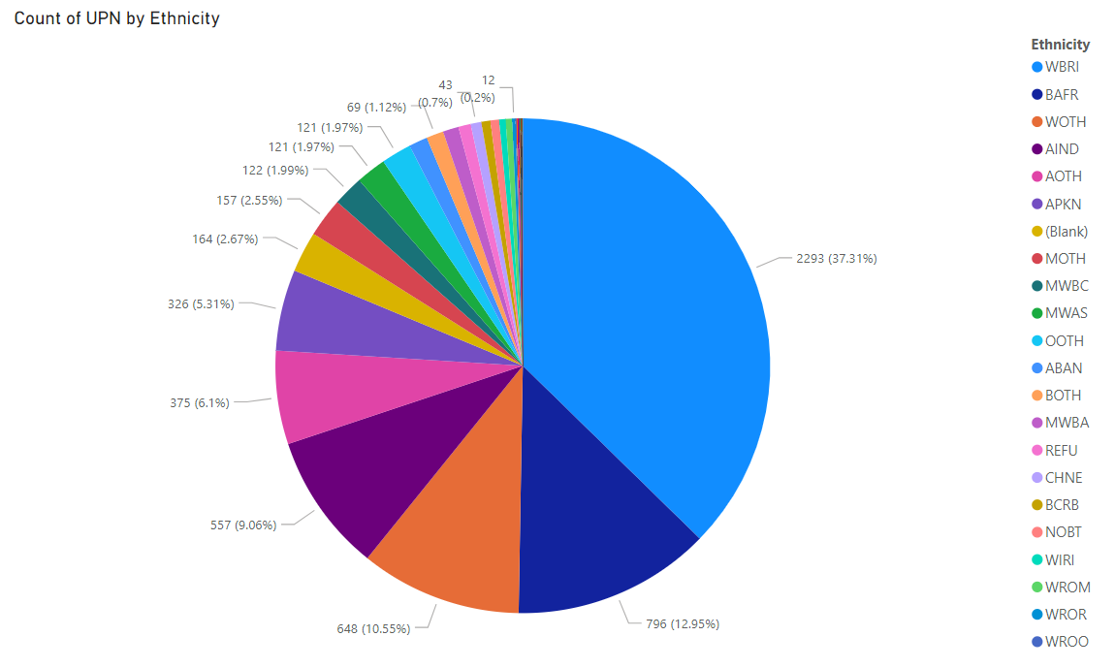
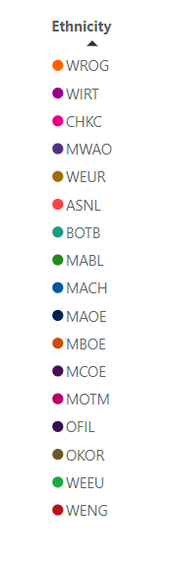
Strategy Annex/Appendix 1

Ethnic mix of current Coventry Music pupils and WCIT delivery 22-23.

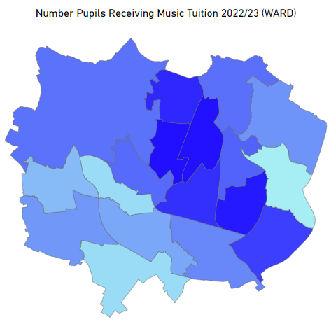
Appendix 2 – engagement of current Coventry Music pupils and WCIT delivery 22-23.

